

Gender Inclusive Language

In Documents, Policy, and Direct Service

A Guide for the Colorado Maternal Mental Health

Collaborative & Framework

*Please consider this is a living document. As you lean into gender inclusive language, you will find what works best for your organization and what does not. Please personalize this guide with your own learnings. This guide is meant to be a tool to use going forward. It should not be considered the only definitive voice on certain issues, nor should it be thought of as a destination. Rather, it is a map to get you started on your journey.*

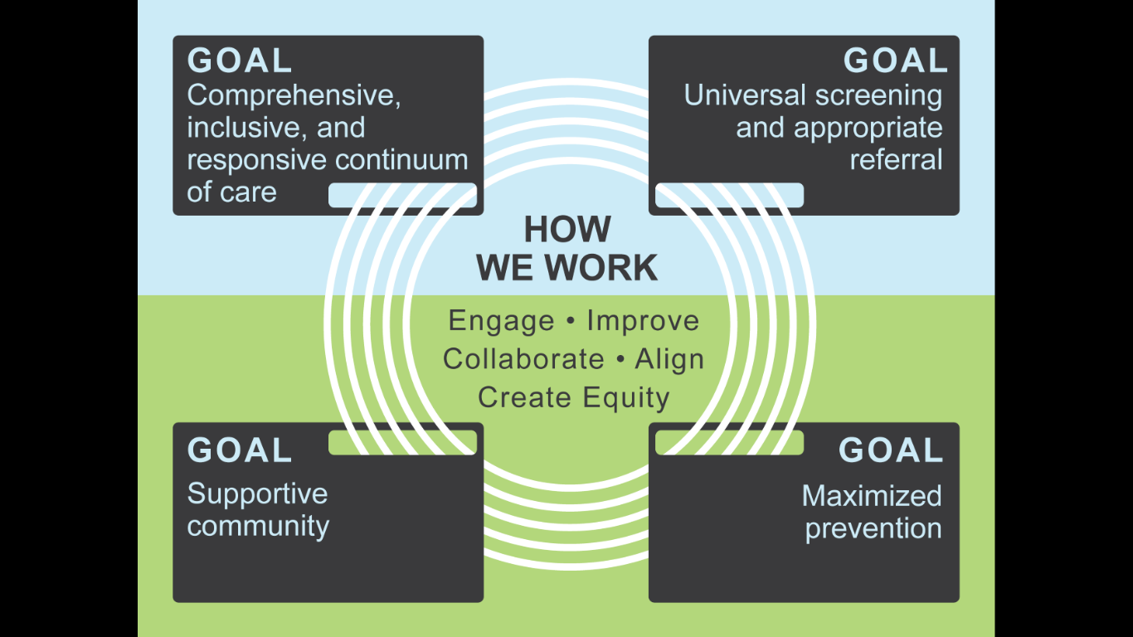

*This guide was originally developed for The Maternal Mental Health Collaborative and Framework in Fall 2019 as a resource to support aligned efforts for a more equitable and inclusive approach to perinatal mental health and was funded by the Colorado Department of Public Health and Environment (CDPHE).*

**Authorship**

*Heather Thompson of Elephant Circle was the primary author of the first version of the guide and consulted to the Collaborative on best practices in using inclusive language. Heather Thompson, MS, PhD, is a molecular and cellular biologist, clinical researcher, birthworker, and non-binary, queer parent. She has worked on issues related to reproductive health for more than 25 years, advocating for equity, access and autonomy in childbirth. From 2010-2017 she was the Research Director at a community birth center in Colorado, advocating for midwives and community birth through data generation, analysis and dissemination. Currently she is the Deputy Director of Elephant Circle, a birth justice organization, doing work that allows her to combine her background in birth access and equity with science and community organizing. She is passionate about supporting the family unit and helping families navigate their own journey, particularly as it relates to maternity care, birth choices and legal cannabis. Born and raised in Colorado, Heather uses she/ her/hers pronouns and enjoys being outside around a campfire with her partner, two kids and larger community.*

*In October 2019, Heather presented a learning session to the Collaborative about the guide specifically and fostering inclusivity for LGBTQUAI+ families more broadly. In December 2019, Jefferson County Public Health’s Milk Power Team offered additional review and feedback to inform this second edition of the guide. The Collaborative wishes to thank CDPHE for providing financial support of the creation of the first edition of the document, Heather Thompson for authorship and guidance, and the Jefferson County Public Health Milk Power Team for offering additional insights. A recording of the webinar is available by contacting the Collaborative at* [*coloradomaternalmentalhealth@gmail.com*](mailto:coloradomaternalmentalhealth@gmail.com)*.*

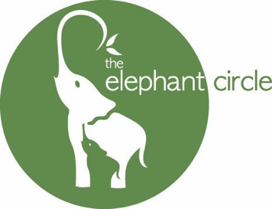

Table of Contents

Why gender inclusive language matters 4

The binary sex and gender are a social construct. 5

Grounding this work in real experiences of the LGBTQIA+ community 6

Specific language suggestions 9

Thinking about pushback 11

Useful learnings from those who have gone before 12

A few final words 13

Glossary 14

A note about pronouns 15

Resources for further education 16

References 21

Why gender inclusive language matters

There have always been folks who give birth and do not identify as woman or female or mom. Recent cultural events have increased the visibility of this community, highlighting the need for less gendered language for pregnancy, birth and breastfeeding. Intentionally using gender-inclusive language allows organizations to speak to a wider audience, increasing visibility for the LGBTQIA+ community. This, in turn, increases the mental health of this sometimes vulnerable community.

------------------------------------------------------------------------------------------------------------------------

“By making room for all bodies and not just bodies that fit into what we currently call *boy* and *girl*, we come back to nature’s circular ways.

When we remember that no two bodies are identical, even the ones we consider the same kind of body, the circle expands more. Until every body is included.

This is the way of nature. Expansive and inclusive.

In fact nature’s strength and endurance is maintained through just this kind of

difference and possibility….every body is present.

Every body connected.

Every body fulfilling an important part of the whole.”

*Maya Gonzalez, author and creator of the Gender Wheel (see page 17 for more)*

-------------------------------------------------------------------------------------------------------------------------

The binary sex and gender are a social construct

***It hasn’t always been this way, this history of binary sex and gender***

It is important to start with the understanding that binary sex and gender are a construct. They were created through colonialism and patriarchy. Decisions made by scientists and doctors about “nature” are particular moments in time.

Settler colonialism, as seen in the United States, was the beginning of binary sex and gender in North America. Before colonization, there were as many as six traditional gender orientation roles among numerous tribes1. Colonization altered the indigenous sense of self, identity, and gender relations. In this way, modernity/coloniality implemented European understandings of gender and sex, erasing the various ideas of sex and gender that pre-existed European modern/colonial gender systems. Western colonizers introduced the concept of gender and it became a tool for domination that designates two binary oppositions and hierarchical social categories; women became defined by their subordinate relation to men in all categories2.

Throughout the late 19th and early 20th century, scientists and doctors instilled an increasingly rigid set of rules about how anatomy defined binary sex (and, by extension, gender). When DNA and genes were discovered, the existence of XX and XY chromosomes in people who mostly fit the definition for “girl” or “boy” was used to further the construct that the sex binary is biologically based. According to historians, defining binary sex rigidly was a construct to “restore order” culturally and societally3.

-------------------------------------------------------------------------------------------------------------------------

“Much recent scholarship has been devoted to documenting the…medical and scientific construction of sex and gender…Such studies show how scientific and medical men* used the minds, tools, and rhetoric to build up powerful ideas about the ‘true’ natures (and limits) of femininity and masculinity.”

*Dr. A Dreger, historian and author of Hermaphrodites and the Medical Invention of Sex.*

*\* Dr. Dreger notes that only one woman is mentioned in the history of this campaign*

***Binary sex is not a biologic principle***

Though science (specifically biology is often used to prove the concept of binary sex, biology does not maintain a strict binary. We all learned that binary sex is immutable and rooted in biology, but this is an instance in which science was used to uphold and strengthen a cultural construct3. In fact, in the non-human world, non-binary sex can be common4, males can give birth5 and changing sexes can be essential – even preferential – for survival6.

The concept of binary sex/gender has been debunked by both science7 and the law8 becoming a topic culturally important enough for National Geographic to dedicate an entire issue to gender in 20179.

-------------------------------------------------------------------------------------------------------------------------

Legal scholar and judge and Judge Noel Wise commented in Time Magazine that, “The more we are learning about our DNA, the more that biologic sex – from the moment of conception – looks like an intricate continuum and less like two tidy boxes. This understanding makes it virtually impossible for judges to consistently apply a law that permits or prohibits conduct based on whether someone is a man or a woman.”

# Grounding this work in real experiences of the LGBTQIA+ community

***Real stories, real experiences.\****

1. A 32-year-old male, Sam, is brought into an ER by his boyfriend,  He complains of abdominal pain that has lasted all night long. His blood pressure and pulse are elevated, and he tells the nurse that he lost his insurance and has not taken his high blood pressure medication in two years. Sam’s emergency medical record says he is male, and the man says he is transgender and took a positive pregnancy test that morning. Labs are drawn and he is diagnosed as an obese man with uncontrolled hypertension. He is determined to be stable and non-urgent. Another provider in the ER checks up on Sam in several hours as his pain has increased and discovers that the pregnancy test was positive, and Sam is in labor with ruptured membranes and a prolapsed cord. Though Sam is immediately rushed to the OR, once there, there is no fetal heartbeat detected by ultrasound and Sam is taken to the L&D floor to birth a stillborn baby10.
2. B is a 19-year-old nonbinary individual who had a planned pregnancy with their husband. B had an uneventful pregnancy and gave birth to a healthy baby. Postpartum, B started to feel very anxious. They could not fit in any of their pre-pregnancy clothing. They were committed to a year of chestfeeding and could not wear a chest binder. They could not take their testosterone injections. Additionally, B’s community did not come and visit or spend time with B, as they were mostly young adults without children. B’s medical providers determined B had postpartum depression, though B firmly expressed they felt their distress was due to their life circumstances. B also expressed concern about using the existing mental health resources for PPD because they were not designed for nonbinary people. B’s provider threatened to call Child Protective Services if B did not pursue treatment for PPD, as they would be at a greater risk of harming their child. B felt forced to attend the support groups and follow treatment, which did not help their anxiety. B’s mental health deteriorated, and they required hospitalization for their gender dysphoria related anxiety and depression. B stopped chestfeeding at 8 weeks.
3. C is a nonbinary person who is autistic. They coparent a newborn with their partner Z, who is a transgender woman. After giving birth in a birth center, C and Z were excited to receive visits from a visiting nurse provided by their insurance. The family gave a message to the providing agency that C is autistic, does not like to be touched by strangers, and uses they/them pronouns. The nurse that received these instructions did not take them too seriously. She entered the home and immediately squeezed C’s arm. She referred to C as “she” and “mama” through the visit. She asked where the father was multiple times. C and Z declined any further contact with visiting nurses.

*\* thanks to Zoë Williams for sharing several of the narratives and statistics.*

***Statistics.***

* It is believed that 1.4 million is the most up-to-date approximation of the number of people who are transgender in the US, but there are currently no federal agencies such as the US Census Bureau or the Center for Disease Control and Prevention (CDC) that accurately assess the true number. Stigma and discrimination against the population are two of many factors that prevent individuals from openly identifying and reporting themselves as transgender11.
* Child psychologists believe that some transgender children will know and assert their gender identity as early as between 2 and 3 years12.
* According to a Human Rights Campaign Paid Leave survey, financial concerns are the greatest factor forcing LGBTQ people to return to work early — or forgo taking time off entirely. Sixty percent of respondents report taking less leave than they needed because they could not afford to lose any more wages13.
* 19% of people who are transgender or gender-nonconforming have experienced homelessness at some point in their lives. Of those transgender adults who tried to access a shelter, 55% were harassed by shelter staff or residents, 22% were sexually assaulted by shelter staff or residents, and 29% were turned away from a shelter altogether14.
* Each episode of LGBT victimization, such as physical or verbal harassment or abuse, increases the likelihood of self-harming behavior by 2.5 times on average15.
* Family acceptance and empathetic care by providers are considered two of the highest ranking protective factors in LGBTQIA+ health concerns16.
* Unplanned pregnancies and sexually transmitted infections are on the rise among LGBTQIA+ youth16.
* La Leche League International has asserted the importance of supporting nonbinary and transgender individuals in identifying and meeting their chest/breastfeeding goals through empathetic care and support as needed.
* The potential for gender dysphoria can increase during the perinatal period for transgender and gender non-conforming individuals17–19, which can increase mental health concerns20.
* The proportion of same-sex couples raising kids tends to be higher in more socially conservative areas of the country. Overall, the highest proportions of same-sex couples raising children under age 18 reside in Southern, Mountain West, and Midwestern states – areas with the fewest protections for LGBTQ families21.
* Racial and ethnic minorities who are LGBTQ are more likely to be raising or having kids. More than a third of same-sex couples raising children are racial or ethnic minorities– approximately 12% are African American and 15% Latinx22,23.
* LGBTQ individuals and same-sex couples raising children have lower incomes than different-sex counterparts and higher levels of poverty. Nearly one in five children being raised by same-sex couples (24%) live in poverty compared to 14% of children being raised by different- sex couples23.
* Contrary to some stereotypes, families from racial minorities are more supportive of their transgender members than are white families. The percentage of families judged “as strong today” as they were before the transgender person came out and/or transitioned are24:
* 55% of African‐American families
* 49% of Asian‐American families
* 47% of Latino/a families
* 48% of American Indian families
* 45% of white families

-------------------------------------------------------------------------------------------------------------------------

“Human diversity is real. Defining that diversity is political.

Honoring diversity as experienced by those whose definitions of themselves

have not been seen, read, heard or honored is essential.”

*Indra Lusero, Esq, Elephant Circle blogpost*

-------------------------------------------------------------------------------------------------------------------------

# Specific language suggestions

|  |  |  |
| --- | --- | --- |
| **Instead of** | **How about** | **Also** |
| Pregnant woman | Pregnant person, gestating person, gestating parent, person planning to give birth, birth giving person |  |
| Mom | Parent, gestating parent, birthing parent, birth giving person, birth giving person, foster parent, adoptive parent, nursing parent, breastfeeding parent, chestfeeding parent, primary caregiver, female caregiver, female-bodied caregiver (remember that “mom” can also be a non-nursing parent partnered with a nursing parent) | If you are speaking to a group, be specific about the person you mean. If you are speaking to an individual, you might ask them what words they like to use for themselves. |
| Moms and Dads | Parents, families |  |
| Mothers in a worksite setting | Employees, staff |  |
| Breastfeeding Room, Mother’s Room | Lactation Room | If the space is multi-purpose and prioritized for lactation can name it Wellness Room, Relax Room, etc. |
| Maternal | Perinatal, prenatal, postpartum, parental, family | Again, be specific. Who exactly are you talking to? Are you talking about the health of the primary care giver or the pregnant/nursing parent? Can this context support the word parent or family? |
| Breastfeeding mom/woman | Nursing person, nursing parent, chestfeeding parent |  |
| Breastfeeding | Breast/chestfeeding, lactation, nursing |  |
| Breastmilk | Human milk |  |
| “Hello ladies and gentlemen!” “Hello boys and girls!” | Hello all, Hello - and welcome to our gathering, Greetings folks, Hello – we are so glad you are here with us, Hello y’all. | Don’t be afraid to be creative here. I recently heard someone welcome a group with “Hello fabulous humans!” |

The above chart includes additions from the Jefferson County Public Health Milk Power Team’s Lactation Language Guide.

For an excellent guide on inclusive language in a broader sense, please reference Colorado State’s Inclusive Language guide found at <https://collegian.com/wp-content/uploads/2018/11/Inclusive-Language-Guide_10_30_18.pdf>25.

***Considerations for documents***

* When talking or writing for groups, use the most inclusive language possible. Sometimes this means using a number of terms rather than a single gendered one. Don’t be afraid to use more words than you might have before. Also, when a specific, narrow term is in fact what you mean, that is great! This is about being intentional in your language.
* In documents meant for a large audience or intended to draw folks to your collaborative/framework, use gender inclusive language early in your document and include gendered language when needed. There is no need to make a document entirely gender-inclusive, a balance between gendered and non-gendered language is the goal.
* If you are quoting someone else’s work, or referring to research that focused on a specific gender, go ahead and use the language of the original work. If the original doesn’t fit your audience, note it in a footnote, or at the beginning of the document take note of how you will use language throughout.

***Considerations for policy***

* Always start by considering your table (your board, your org, your stakeholder group). Who is your table set for? Who is sitting there? Who is missing?
* Question potential outcomes for your policy – who will it help? Who might it harm? If the folks at your table can’t answer the second question, you need some more perspectives.
* Consider unintended consequences. Lactation rooms are a perfect example of this as rooms are often named something like “Mother’s Breastfeeding Room” or “Mom/baby Room” or “Room for Nursing Moms.” All of these exact names have been used to exclude chestfeeding dads in Colorado. They may also have the effect of reinforcing a gendered division of labor, making it less likely that a dad would be in charge of baby feeding.

***Considerations for direct service***

* When talking to an individual, use the words and terms they would like you to use. Don’t know their pronouns – feel free to ask! No need to guess at their parent name, ask them what they like to be called. Some folks are ok to be called Mama or Papa by their children, but not by others. Put simply, call people what they want to be called and ask for information, but make sure it is information you really need to know.
* In documents that collect client information, provide as many ways for a client to tell you about themselves expansively. If you use boxes to help folks categorize themselves, include as many options as you can including “other” with a box to say what other might be. This can be tricky from a data collection point of view, but think expansively about this. How can you balance the work of data collection with making folks feel seen?

# Thinking about pushback

***“I am worried that using gender inclusive language will make women feel excluded.”***

This is a common concern that you should anticipate on this journey. Because this idea can be such a barrier to further conversation, Elephant Circle decided to collect some data about folks’ experience following gender inclusive language during their prenatal education. This “experiment” involved interviewing over 250 pregnant people by asking three specific questions:

1. Did you notice the gender inclusive language that was used?
2. Did it bother you?
3. Did it take away from your own experience or journey?

The details can be found at <http://www.elephantcircle.net/circle/2017/4/13/my-gender-neutral-language-experiment>, but the primary takeaways are below.



# Useful learnings from those who have gone before

In 2014, the Midwives Alliance of North America (MANA) changed the language in their core competency documents to be a better balance of gendered and non-gendered language.

***The success:*** MANA’s commitment to gender-inclusive language - despite intense pushback - meant that LBGTQIA+ folks could convene at a national MANA conference. Out of this gathering, they created the non-profit organization, the Queer and Transgender Midwives Alliance. This organization, by and for queer and transgender midwives, is part of the solution to culturally competent care.

***The resistance:***

There was tremendous pushback and there were people who felt that this language change marginalized women. An “Open Letter” was written to MANA expressing dismay at the change and was signed by hundreds of midwives.

***A response to the resistance:***

Trevor MacDonald, a transgender dad, lactivist, and author, wrote this eloquent response to the Open Letter. It is useful on many levels, and the last two sentences are particularly important.

*“Like the authors of the Open Letter, I do not wish to erase the word ‘woman,’ nor do I deny the life-giving power of women. Women are a group who have been and continue to be oppressed in many ways by a patriarchal society. This includes women having a terrible lack of control over their bodies during the birth process. I have deep respect for this struggle.*

*Yet, trans, genderqueer and intersex people have been giving birth for as long as women-identified people have, and we have also encountered oppression. The Open Letter presumes that to be trans and to give birth is some new phenomenon of the last few years. Trans people giving birth are newly visible because today we are able to transition hormonally and surgically as well as engage our bodies in pregnancy, but there have always been people who identified differently from women whilst experiencing birth.*

*I believe those who wrote the Open Letter feel that they as women would be made invisible by the exclusive use of the words ‘pregnant individuals.’ They fear a future where they will not be allowed to write or speak about women in their own practices. For some, becoming pregnant and giving birth is a crucial aspect of their womanhood, not their personhood.*

*We do not need to choose between celebrating women and including people of all genders. Why can't midwives serve ‘women and people of all genders?’ Organizations trying to grapple with respecting the feminist legacy of midwifery care while using inclusive language should be generous with their ink. Queer folks have done well to add more letters to our ‘alphabet soup’ LGBTTQIA acronym. We can all handle a few more letters.”*

# A few final words

* Remember that becoming a more inclusive collaborative is an iterative and circular process.
* Ground your work in empathy and engage stakeholders when you need feedback.
* Be willing to prototype (to the extent you can), receive more feedback, and innovate.
* Perfection is an adversary in this work – don’t worry about being perfect!
* Mistakes are inevitable, embrace them as a time for learning and improving.
* Pushback is common, stay present with the reason this was important to the work of your collaborative.
* Innoculate everyone in your collaborative about why this work is important to the work you are doing.
* There are folks out there who feel seen because of your work on being more gender inclusive, even if you don’t hear from them.
* Gender inclusive language is a concrete step to increasing expansiveness in your organization. Diversity happens as a result of creating an environment where folks with a wide variety of identities want to participate.

-------------------------------------------------------------------------------------------------------------

“You don’t have to understand.

You don’t have to agree.

You simply have to show respect and empathy.”

*Zoë Williams, educator and organizer*

---------------------------------------------------------------------------------------------------------------

# Glossary

**Assigned sex at birth**: The sex marker (M or F) that a person was assigned at birth, generally associated with how the body/genitals look

**Assigned gender at birth**: Babies are generally assumed to identify with the gender that corresponds to their assigned sex at birth and are assigned that gender from the moment they are born (sometimes even before).

**Transgender**: *Trans* means across or opposite from. Transgender folks identify with a body and/or gender that is **not** what they were assigned at birth. Some transgender folks are binary (i.e. transgender man or transgender woman) and some transgender folks have non-binary gender. The term transgender is not reflective of gender identity or expression, sexual orientation, or a person’s hormonal or body biology.

**Cisgender**: *Cis* means on the same side. For cisgender folks, their sex and gender are both on one side of the binary. The term cisgender is not reflective of gender identity or expression, sexual orientation, or a person’s hormonal or body biology.

**Gender non-conforming (GNC)**: Any gender outside the binary. Can include non-binary and trans folks.

**LGBTQIA+** (the term most often used to describe this community, a term used in data collection and generally more universally recognized than MOGII):

**L**esbian

**G**ay

**B**isexual/Pansexual

**Q**ueer/**Q**uestioning

**I**ntersex

**A**sexual/**A**gender

**P**lus (can include U = Undecided or 2S = two spirit)

**MOGII** (a term coined by the queer community, only a few years old):

**M**arginalized

**O**rientations &

**G**ender

**I**dentities &

**I**ntersex

**Mx.:** a gender-inclusive honorific, generally pronounced the same as Ms, just with an x (ks) sound.

# A note about pronouns

Do not assume or guess people’s pronouns. Simply ask, what pronouns do you use? Avoid using the term preferred pronoun, it can feel dismissive. Having pronouns on email or other signature lines can be a way to honor gender differences and have the potential increase safety for employees and clients. Pronoun go arounds in large meetings can be problematic and require some intentional planning.

# Resources for further education

This is not an exhaustive list of resources.

Some of these resources are by and for LGB/queer/trans/gender non-conforming folks,

some are designed to educate allies as well.

***As you navigate these resources, please remember that:***

* Individual stories are just that, individual. No individual’s way of being represents everyone’s way of being in that identity group.
* Some of these resources are by and for the LGBTQUIA+ community. If you are not part of that community, please be respectful and aware that folks may not want to provide you education in those spaces, especially for free. If you want to ask someone in the LGBTQUIA+ community a question, please be prepared to compensate them for their physical, emotional, and psychic labor.

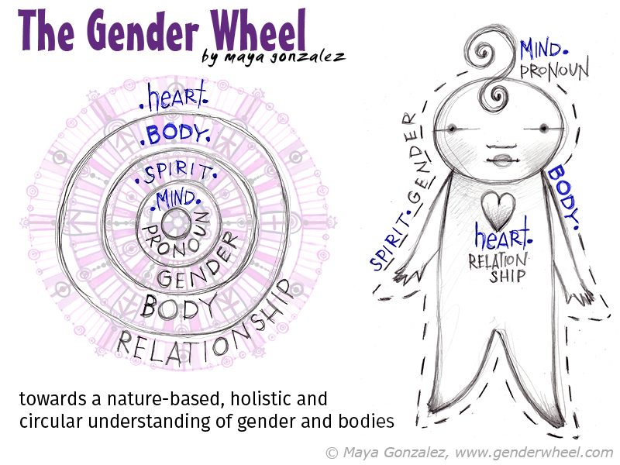

Maya Gonzalez created the Gender Wheel to help us imagine a more fluid, less colonized look at our bodies, our genders and our relationships with other and ourselves. The following quotes are Maya’s own words about the Gender Wheel.

“These four aspects of the self, BODY, GENDER, RELATIONSHIP and PRONOUN aren’t necessarily fixed. For many they are fluid, either all the time or for periods of time. In order to accommodate the holistic self and the infinite possible bodies, hearts, minds and spirits in combination and potentially in motion, I needed a symbol that was natural, dynamic, infinite and inclusive to portray gender in truth.

The Gender Wheel rose from:

1. **Cultural significance** – infinity, eternity, calendars – Mayan and Aztec
2. **Nature** – shapes and patterns of growth, my Mexican American father conveyed a deep love of nature and respect for the cycles of life and death
3. **Circles/Concentric/Movement/inclusive, nonlinear** – holds infinite positions around its circumference and moves forward and backward

More on The Gender Wheel, by Maya Gonzalez at <http://www.genderwheel.com/>

In Maya’s words….

**Body circle**includes familiar markers of: *intersex girl, cisgender girl, transgender boy, intersex boy, cisgender boy, transgender girl* with infinite room in between for more!

**Inside circle** includes many identities and inside feelings: *kid, androgynous, agender, femme boy, femme girl, butch boy, part time boy/part time girl, gender fluid and more and more…*

**Pronoun circle** includes familiar ones and space for more to grow into: *They, She, He, Me, Ze,* and *Tree*.

*Tree* is to affirm that we need more words that reflect the deeper meaning of who we are as queer/trans/intersex people! Especially ones connected to nature. Language is OURS! We must move beyond the binary in how we speak.

**Relationship circle** (the 4th outer circle currently shown faded) will be explored more with [*The Rainbow Alphabet*](http://www.reflectionpress.com/our-books/the-rainbow-alphabet/) and will include familiar markers: *Queer, Lesbian, Gay, Bisexual, Pansexual, Asexual, Heterosexual and more…*

All of the circles turn forward and backward opening up infinite possibilities along their curve and between the circles making room for every body to be exactly who they are.”

**Virtual Services, Classes, Trainings:**

* Kristen Kali, Maia Midwifery, <http://maiamidwifery.com>
* Sandra Londino, Birth Room Midwifery, [https://classroom.sandralondino.com](https://classroom.sandralondino.com/)
* Woven Bodies, <https://www.wovenbodies.com> *(in process)*
* Birthing Beyond the Binary, [https://birthingbeyondthebinary.com](https://birthingbeyondthebinary.com/)
* Maya Gonzalez, <http://www.genderwheel.com/>
* <https://www.cornerstonedoulatrainings.com/>

**Other projects & places that are LGBTQUAI+ friendly:**

* The Baltimore Doula Project, <https://www.baltimoredoulaproject.org>
* Brown Boi Project, <https://www.brownboiproject.org>
* Preggers Can be Choosers, <https://preggers.rocks>, planning postpartum <https://tinyurl.com/yxshu6nt>
* National LGBT Health Education Center, <https://www.lgtqhealtheduction.org> – check out Pathways to Parenthood for LGBT people
* La Leche League, <https://www.llli.org/breastfeeding-info/transgender-non-binary-parents>
* Masculine Birth Ritual (a podcast), [https://www.masculinebirthritual.com](https://www.masculinebirthritual.com/)
* <https://helloclue.com/articles/cycle-a-z/thinking-about-pregnancy-as-a-nonbinary-trans-person>
* <https://transpregnancy.leeds.ac.uk/2019/07/11/read-and-listen-trans-pregnancy-in-media-health-and-law>

**Stories:**

* Trystan Reese: <https://www.facebook.com/watch/?v=511104082742097> and <https://www.biffandi.com/>, also presents Unicorns and Horses through Cornerstone Doula Trainings
* <https://nypost.com/2017/12/21/transgender-dad-says-he-preferred-pregnancy-as-a-man>
* <https://www.self.com/story/finding-the-right-doula>
* <https://www.facebook.com/HobbsPhotography/posts/2467195410000891:0?hc_location=ufi>
* <https://www.washingtonpost.com/dc-md-va/2019/08/16/non-binary-pregnant-navigating-most-gendered-role-all-motherhood/>
* A film project, “A Womb of Their Own.”

**Facebook groups:**

* The Other Box
* Birthing and Breast or Chestfeeding Trans people and allies

**Podcasts** are another terrific resource for hearing stories outside your own experience.

There are too many to list, but please consider them an important resource!

That being said, I have been listening to *Se Ve Se Escucha*, a language justice podcast.

Episode 3 is on queering language. Highly recommend!

**Peer-reviewed papers:**

* ***The Power and Limits of Classification*** — A 32-Year-Old Man with Abdominal Pain, D Strousma et al., New England Journal of Medicine, May 2019, ﻿1885-1888
* ***Lactation Care for Transgender and Non-Binary Patients: Empowering Clients and Avoiding Aversives***, Trevor MacDonald, Journal of Human Lactation, 2019, 35(2): ﻿223-226.
* ***Transgender men, pregnancy, and the “new” advanced paternal age: A review of the literature***. JS Brandt, et al., Maturitas, 2019, 128:17-21.
* ***Transmasculine individuals’ experiences with lactation, chestfeeding, and gender identity: a qualitative study***, T MacDonald et al., BMC Pregnancy and Childbirth (2016) 16:106.
* ***Transgender men and pregnancy (a review)***. Juno Obedin-Maliver and Harvey J Makadon, Obstetric Medicine 2016, 9(1): 4–8. <https://journals.sagepub.com/doi/pdf/10.1177/1753495X15612658>

**Books:**

* Queering Reproduction: Achieving Pregnancy in the Age of Technoscience, by Laura Mamo
* Trans Bodies, Trans Selves: A Resource for the Transgender Community, ed by Laura Erickson-Schroth
* The Gender Wheel: a story about bodies and gender for everybody, by Maya Gonzalez
* They, She He, Me: Free to Be!, by Maya and Matthew Gonzalez
* Pregnant Butch: Nine Long Months Spent in Drag, by AK Summers
* Where’s the Mother: Stories from a Transgender Dad, by Trevor MacDonald
* Queer + Pregnant, a personal journal, by Mx. Jenna M Brown
* Subversive Motherhood: Orgasmic birth, gender queer parenting, papas, trans parenting, Gynepunk, etc., by Maria Llopis
* And Baby Makes More, by Susan Goldberg
* The New Essential Guide to Lesbian Conception, Pregnancy, and Birth, by Stephanie Brill

# Love over Fear Wellness and Birth queer pregnancy workbook, by Mx. Jenna Brown

# The Ultimate Guide to Pregnancy for Lesbians, by Rachel Pepper

# Confessions for the Other Mother, by Harlyn Aizley

# Buying Dad: One Woman’s Search for the Perfect Sperm Donor, by Harlyn Aizley

# The Ultimate Guide for Gay Dads, by Eric Rosswood

# What Makes a Baby, by Cory Silverberg and Fiona Smyth

# Meet Polkadot, by Talcott Broadhead

# References

1. Cameron, M. Two-spirited Aboriginal people: Continuing cultural appropriation by non-Aboriginal society. *Can.* W*oman Stud.* **24**, (2005).

2. Lugones, M. Colonity of Gender. *Worlds & Knowledges Otherwise* **2**, 1–17 (2008).

3. Dreger, A. *Hermaphrodites and the medical invention of sex*. (Harvard University Press, 1998).

4. Adams, J. Going Through Life as Half She, Half He. *National Geographic* (2017).

5. Seahorse Fathers Take Reins in Childbirth. *National Geographic* (2002).

6. Todd, E. V. *et al.* Stress, novel sex genes, and epigenetic reprogramming orchestrate socially controlled sex change. *Sci. Adv.* **5**, eaaw7006 (2019).

7. Ainsworth, C. Sex redefined. *Nature* **518**, 288–291 (2015).

8. Wise, N. Bathroom Bills, Transgender Laws at Odds with Science. *Time* (2017).

9. *Gender Revolution - National Geographic Magazine*. *National Geographic* (2017).

10. Strousma, Daphna; Roberts, Elizabeth; Kinnear, Hadrian; Harris, L. H. The Power and Limits of Classification — A 32-Year-Old Man with Abdominal Pain. *N. Engl. J. Med.* 1885–1888 (2019).

11. Meerwijk, E. L. & Sevelius, J. M. Transgender Population Size in the United States: a Meta-Regression of Population-Based Probability Samples. *Am. J. Public Health* **107**, e1–e8 (2017).

12. Rafferty, J. Ensuring Comprehensive Care and Support for Transgender and Gender-Diverse Children and Adolescents. *Pediatrics* **142**, e20182162 (2018).

13. Human Rights Foundation. 2018 Leave Survey. (2018).

14. Grant, Jaime M.; Mottet, Lisa; Tanis, J. Injustice at every turn. *Natl. Transgender Discrim. Surv.* 1–221 (2011).

15. Facts About Suicide – The Trevor Project. Available at: https://www.thetrevorproject.org/resources/preventing-suicide/facts-about-suicide/. (Accessed: 6th September 2019)

16. Hafeez, H., Zeshan, M., Tahir, M. A., Jahan, N. & Naveed, S. Health Care Disparities Among Lesbian, Gay, Bisexual, and Transgender Youth: A Literature Review. *Cureus* **9**, e1184 (2017).

17. Obedin-Maliver, J. & Makadon, H. J. Transgender men and pregnancy. *Obstet. Med.* **9**, 4–8 (2016).

18. Light, A. D., Obedin-Maliver, J., Sevelius, J. M. & Kerns, J. L. Transgender Men Who Experienced Pregnancy After Female-to-Male Gender Transitioning. *Obstet. Gynecol.* **124**, 1120–1127 (2014).

19. MacDonald, T. *et al.* Transmasculine individuals’ experiences with lactation, chestfeeding, and gender identity: a qualitative study. *BMC Pregnancy Childbirth* **16**, 106 (2016).

20. Dhejne, C., Van Vlerken, R., Heylens, G. & Arcelus, J. Mental health and gender dysphoria: A review of the literature. *Int. Rev. Psychiatry* **28**, 44–57 (2016).

21. Day, S. LGBTQ Family Fact Sheet. *Fam. Equal. Counc.* 1–4 (2017).

22. Pew Research Center. A Survey of LGBT Americans Attitudes, Experiences and Values in Changing. (2013).

23. Gates, G. J. *LGBT Parenting in the United States*. (2013).

24. FORGE. Family Matters : Fast New Facts about Transgender People and SOFFAs ( Significant Others , Friends , Family and Allies ). (2011).

25. Colorado State University. *Inclusive Language Guide*. (2018).